**Charity Funding Predictor Analysis**

**Overview:**

The purpose of this analysis is to show what was done for the algorithm to achieve the results stated below. This is an attempt to create a binary classifier that can predict whether or not the charity funding will be successful.

Graph:

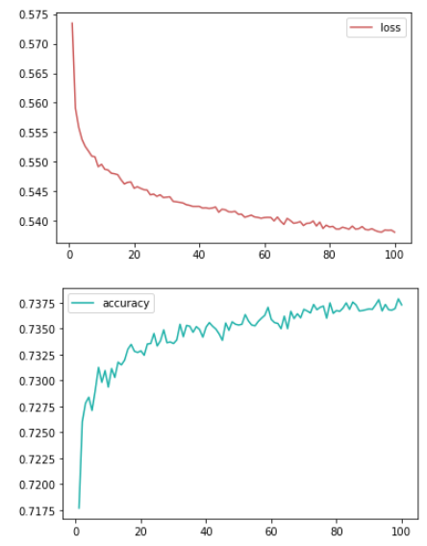

model w/o opt - 0.7374 - 2 layers: 80, 30 - activation='relu' - epochs=100

**Summary:**

It is clear in our graphs how the modifications change the results of the models. The loss and accuracy seem to be relational barring a few outliers. With more data or possible tweaks with current data, we could generate more models to achieve the score we are looking for. I would attempt to add more layers, increase the number of nodes, and add a large number of epochs in order to achieve a higher accuracy score.

I am basing this recommendation off of the two models that were optimized and how they appear to react to the tweaks.